FIRST YEAR

|  |
| --- |
| **BIBLE aTLAS** |
| A Survey of Bible Lands & People |

WORKBOOK

**DELIVERANCE BIBLE INSTITUTE**

*Portland, Maine, USA*

|  |
| --- |
| Bible Atlas |
| A Survey of Bible Lands & People |
|  |

Syllabus 2

Calendar 3

LESSON 1 4

LESSON 2 6

LESSON 3 7

LESSON 4 9

LESSON 5 11

LESSON 6 12

LESSON 7 13

LESSON 8 14

LESSON 9 17

LESSON 10 18

Genesis Assignment Check List 20

LESSON 11 21

LESSON 12 22

LESSON 13 23

LESSON 14 25

LESSON 15 26

LESSON 16 29

LESSON 17 30

LESSON 18 32

LESSON 19 33

LESSON 20 34

LESSON 21 35

LESSON 22 37

LESSON 23 41

LESSON 24 43

LESSON 25 44

LESSON 26 45

FINAL EXAM 47

# Syllabus

What is the Pentateuch?

* The first five books of God’s Holy Word which contain the record of the beginning and origin of all things and shadows of all subsequent Biblical revelation.
* One of the most diverse and powerful studies of the Bible.
* Essentially, the Pentateuch is the foundation of all spiritual truth and social principle!

What does this course involve?

* You will be reading the textbook and responding to the essays by answering questions.
* Each section will conclude with Study Questions that are answered ‘open book’ which prepares you for the test that follows. The test is not ‘open book’ but is taken by memory.
* You will be consecutively reading each of the five books of the Pentateuch at the same time producing a question and answer from each chapter.
* You will be studying on your own various topics relating to the Pentateuch; such as: *The Feasts of the Lord*, and *Murmurings in the Wilderness*.
* You will be memorizing Scripture.
* You will complete an open book Final Exam at the conclusion of this course that will test your understanding of the Pentateuch.

How is this Course Divided?

* This course is divided into five (5) main sections. Each section will conclude with: 1) a special assignment 2) study questions and 3) a test.

1. Section 1: Genesis
2. Section 2: Exodus
3. Section 3: Leviticus
4. Section 4: Numbers
5. Section 5: Deuteronomy

All assignments in this course are either:

### **Open Book**

Resources may be used to answer questions; such as, this textbook, the Bible, commentaries, and etc. *OR*,

### **Closed Book**

No resources are to be used. Closed book assignments are by memory only and are designed to test your memory as well as comprehension.

# Calendar

*NOTE: This calendar is subject to change and is provided only for the purpose of giving the student a general understanding of the what’s and when’s of this course.*

Oct 14 Week 1 INTRODUCTION, *Section 1 – Genesis* begins

21 Week 2 Genesis 1-7 & Q&A due

28 Week 3 Genesis 8-14 & Q&A due

Nov 4 Week 4 Genesis 15-21 & Q&A due

11 Week 5 Genesis 22-28 & Q&A due/ *Section 1 – Genesis* Study Questions due

**18 Week 6** Genesis 29-35 & Q&A due/ **Quiz / ‘Personality Report’**

<<<NOVEMBER 22 thru December 1 – THANKSGIVNG VACATION>>>

Dec 3 Week 7 *Section2 – Exodus* begins

10 Week 8 Exodus 1-10 & Q&A due

17 Week 9 Exodus 11-20 & Q&A due

<<<DECEMBER 20 THRU JANUARY 5 – CHRISTMAS VACATION>>>

Jan 7 Week 10 Exodus 21-30 & Q&A due

14 Week 11 *Section 2 – Exodus* Study Questions due/Exodus 31-40 & Q&A <<NC Trip>>

**21 Week 12** **Quiz / ‘Exodus Sermon’**

28 Week 13 *Section 3 – Leviticus* begins

Feb 4 Week 14 Leviticus 1-10 & Q&A due

11 Week 15 Leviticus 11-20 & Q&A due

<<<FEBRUARY 14 thru 23 VACATION>>>

25 Week 16 *Section 3 – Leviticus* Study Questions due / Leviticus 21-27 & Q&A due

**Mar 4 Week 17 Quiz / ‘Holiness Hot Seat’**

11 Week 18 *Section 4 – Numbers* begins / Numbers 1-10 & Q&A due

18 Week 19 Numbers 11-20 & Q&A due

Mar 25 Week 20 Numbers 21-30 & Q&A due

April 1 Week 21 *Section 4 – Numbers* Study Questions due / Numbers 31-36 & Q&A due

<<<April 4 thru 13 VACATION>>>

**15 Week 21 Quiz / ‘Dialogues’**

22 Week 22 *Section 5 – Deuteronomy* begins / *Deuteronomy* 1-10 & Q&A due

29 Week 23 *Deuteronomy* 11-20 & Q&A due

<<<April 30 thru March 4 – Virginia Convention>>>

May 6 Week 24 *Deuteronomy* 21-30 & Q&A due/

13 Week 25 *Deuteronomy 3*1-34 & Q&A due/ *Section 5 – Deuteronomy* Study Questions due

20 Week 26 **Quiz / ‘Memorize Deut. 6:4-16’**

27 Week 27 FINAL EXAM / ALL ASSIGNMENTS DUE

# LESSON 1

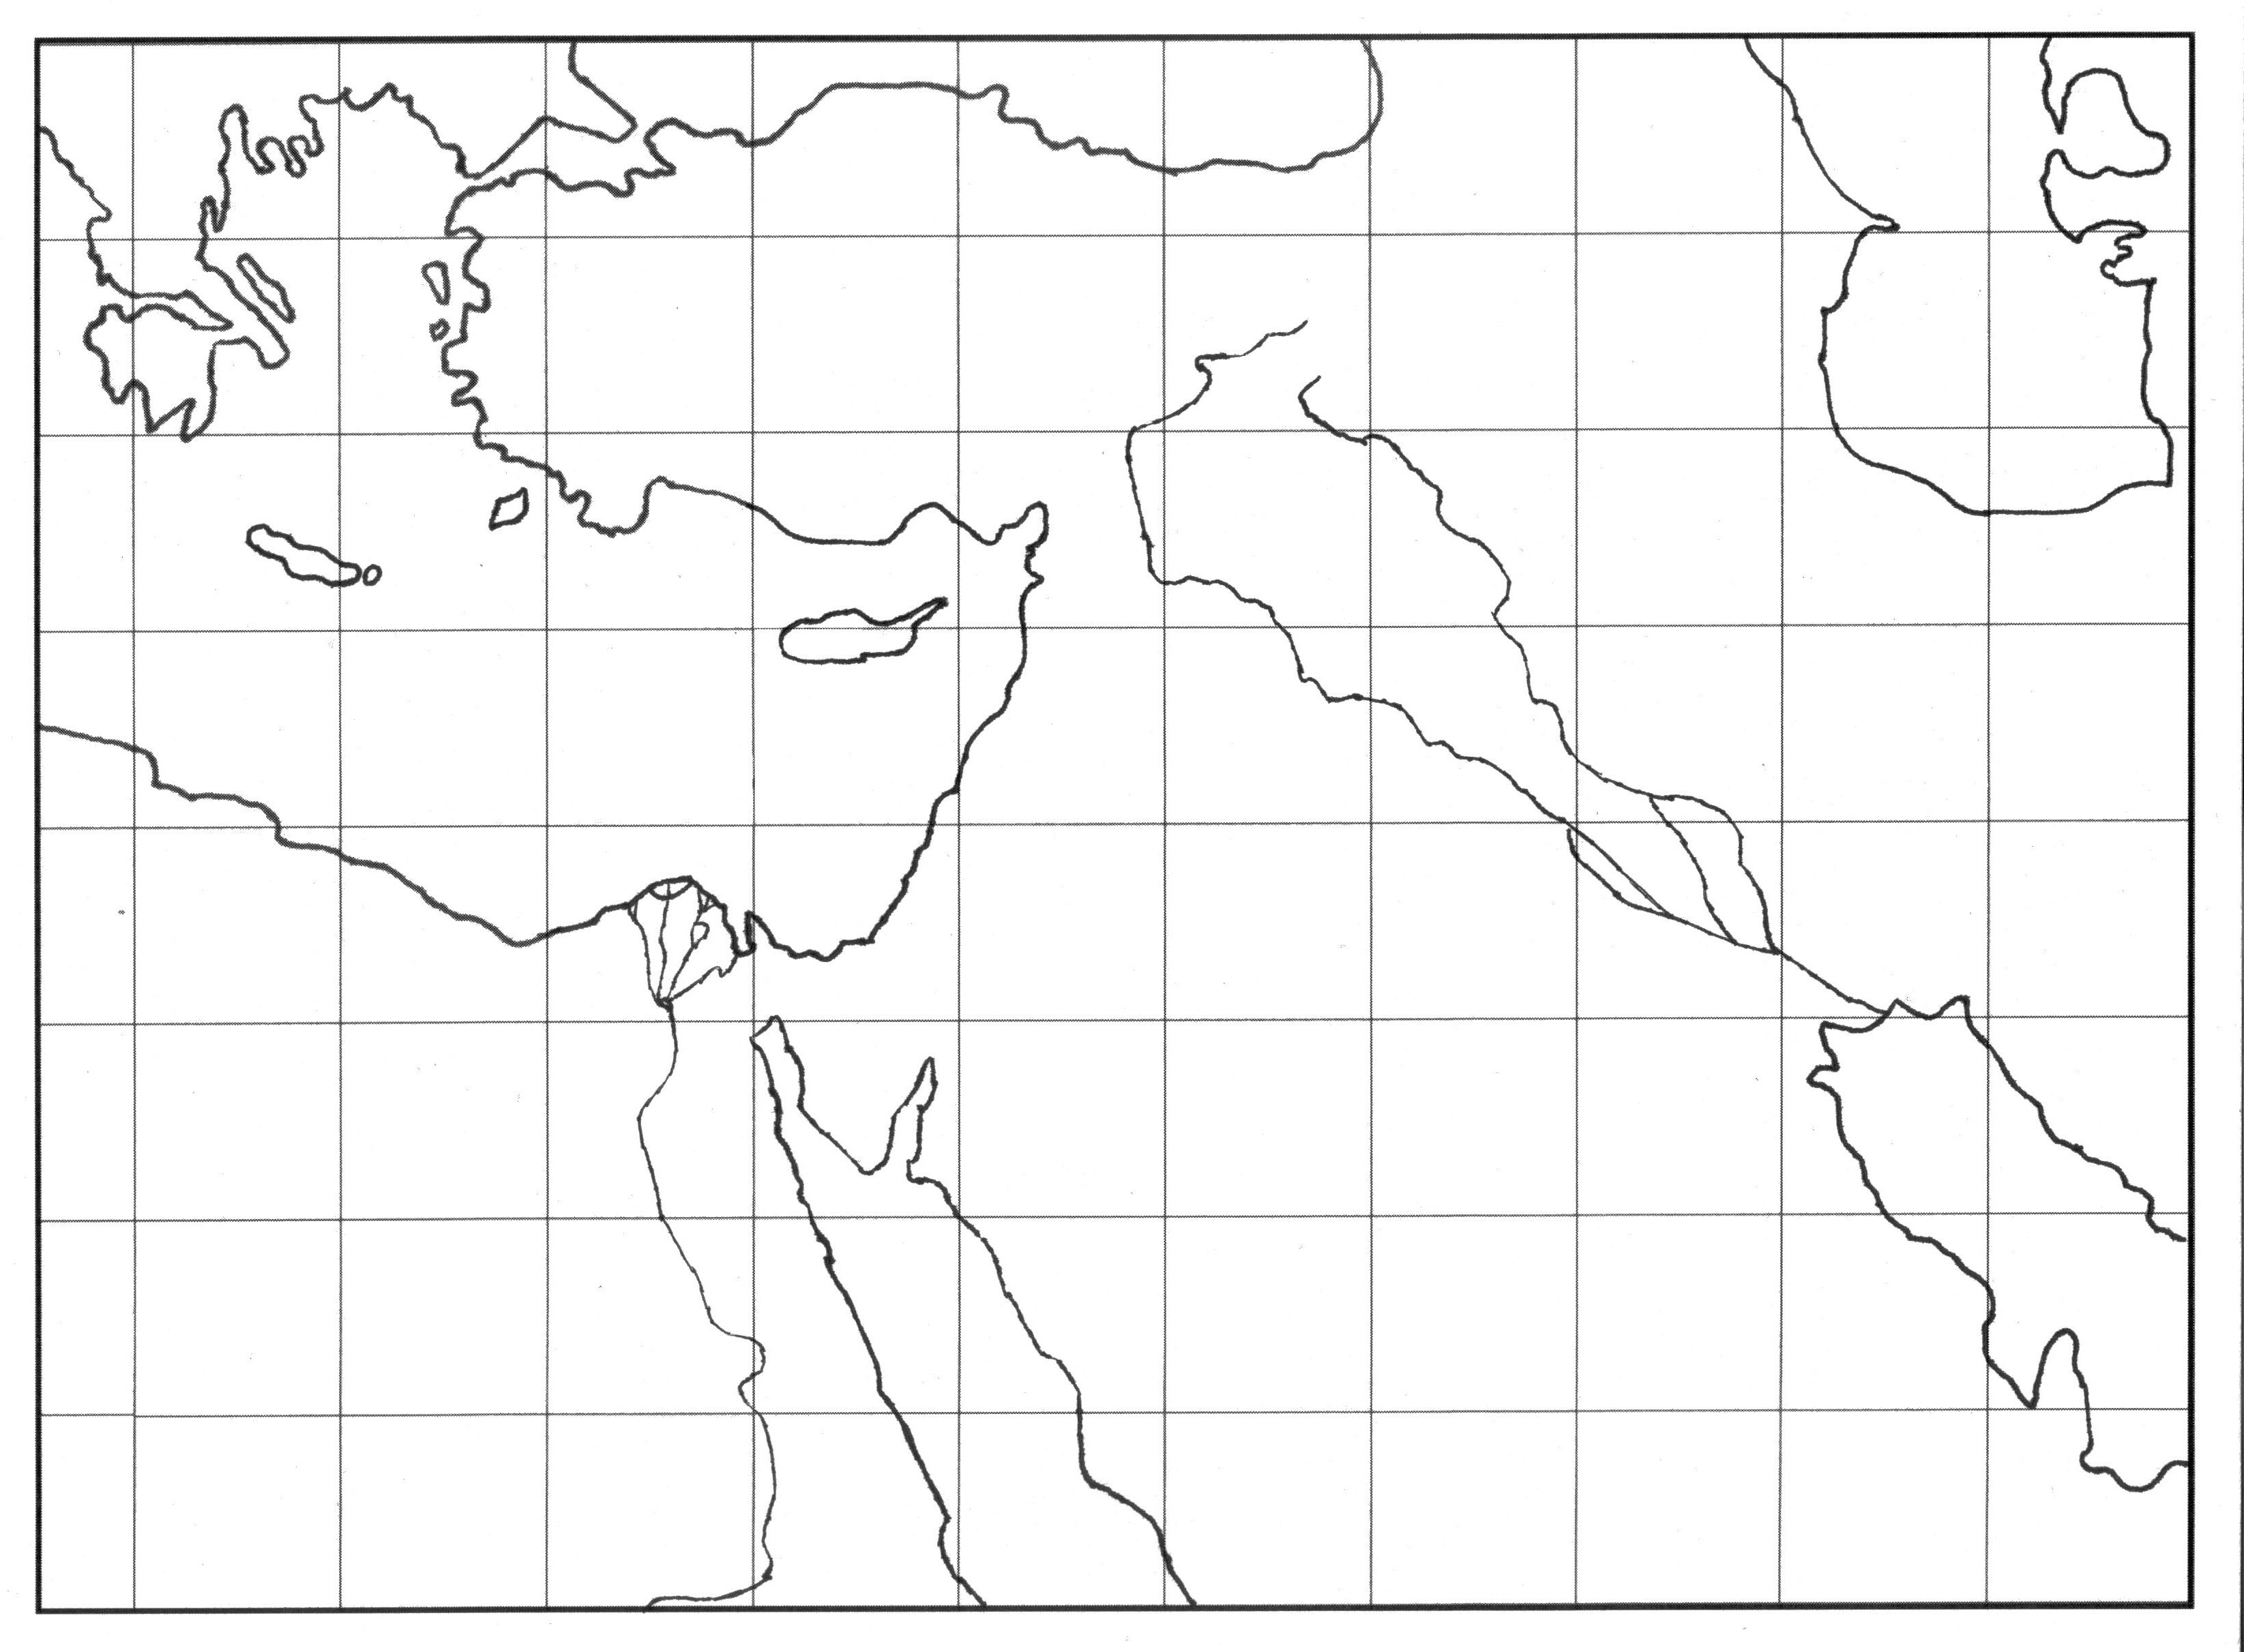

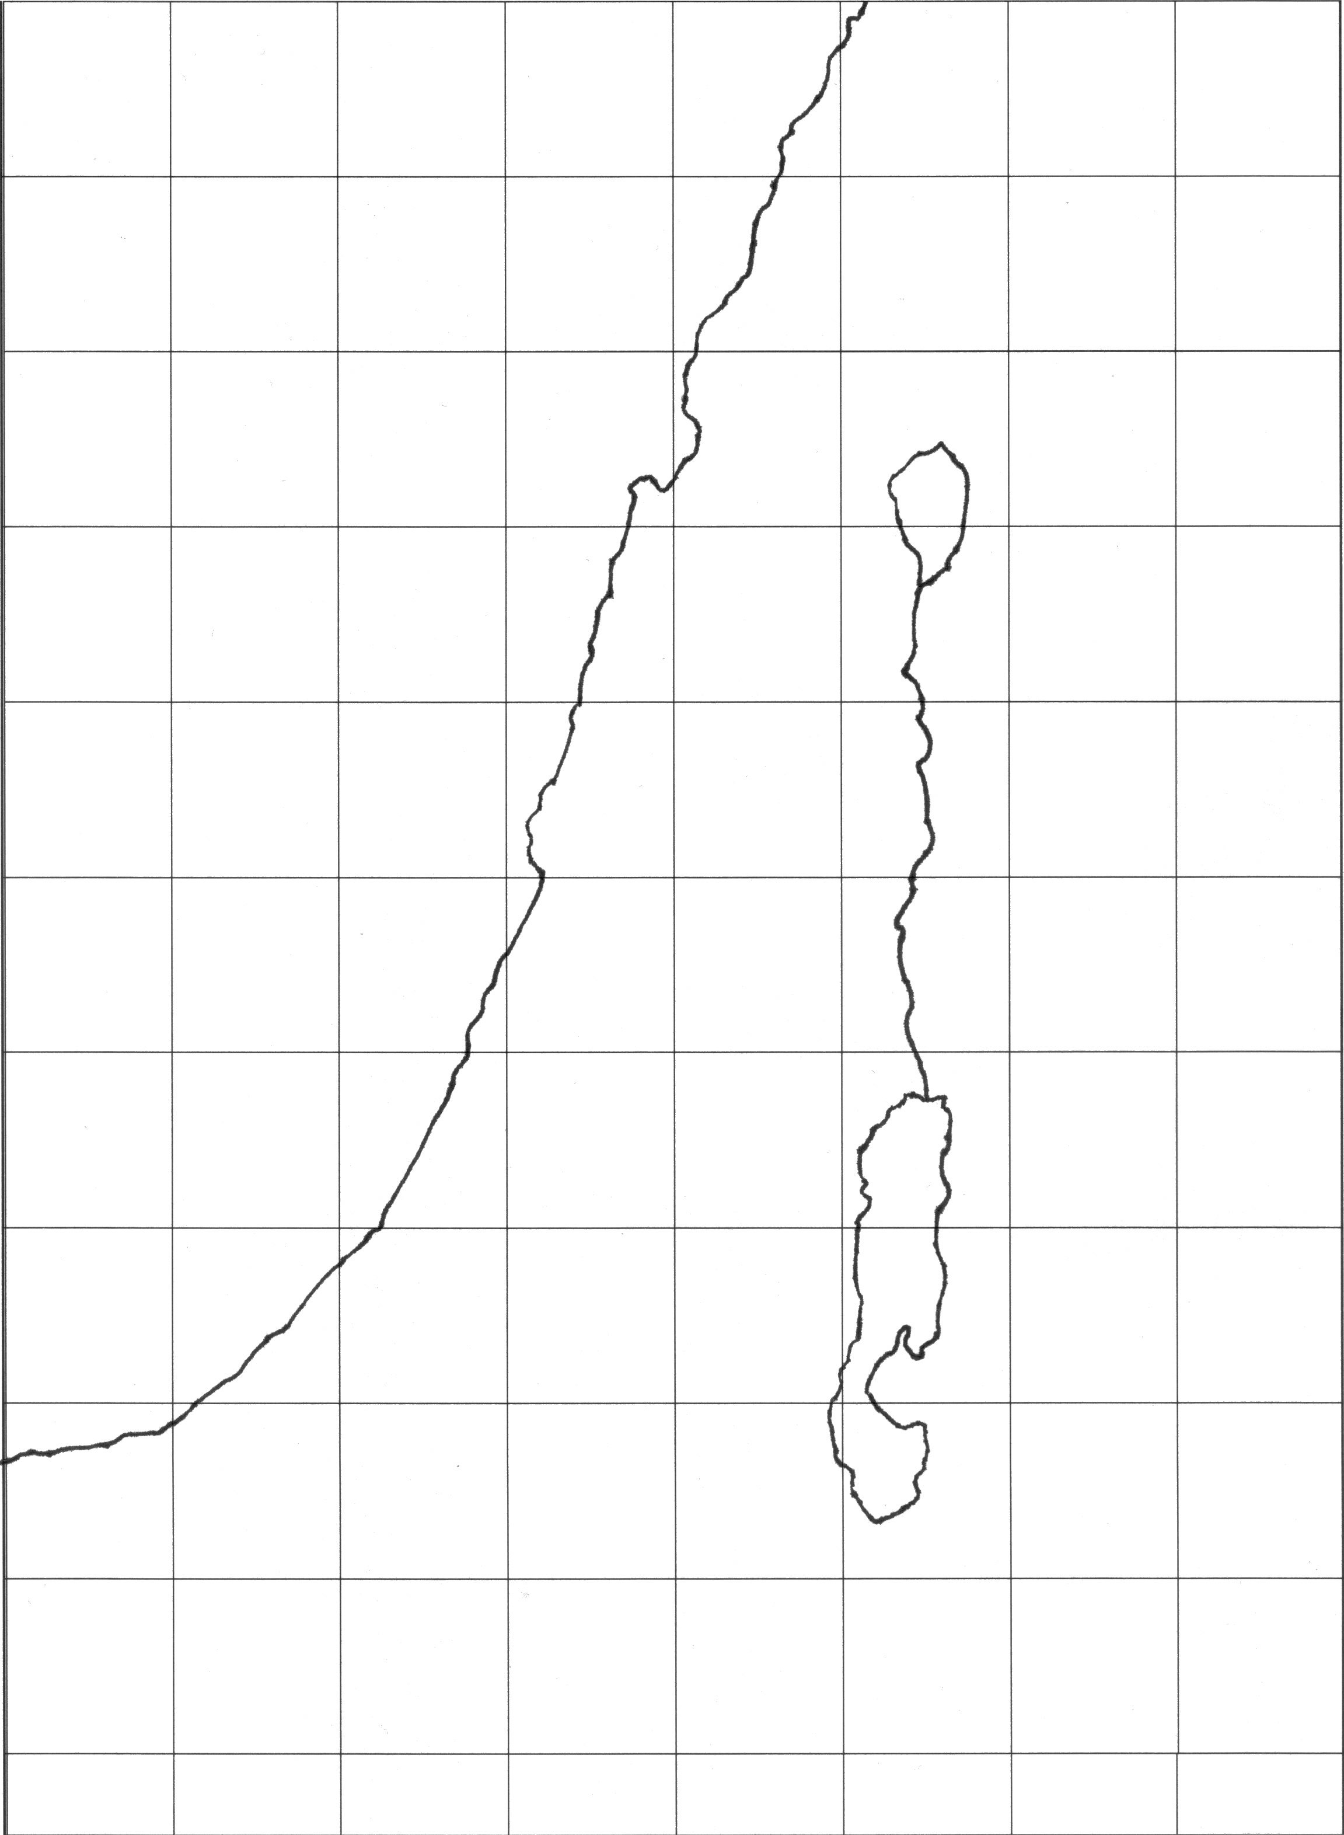

# LESSON 2

# LESSON 3

# LESSON 4

# LESSON 5

# LESSON 6

# LESSON 7

# LESSON 8